LAB # 5
Inter-Thread Communication:
OBJECTIVE:
Develop an inter-thread user communication program by using synchronization.
Lab Task: 1.
Design a simple program of concurrency by implementing the scenario of two account holders in a joint bank account. (Hint: Total amount will be 50000, if ‘user A’ wants to withdraw 45,000 and ‘user B’ wants to withdraw 20,000) Apply mechanism of synchronization e.g. Block or Method for handling accessibility of multi-threads:
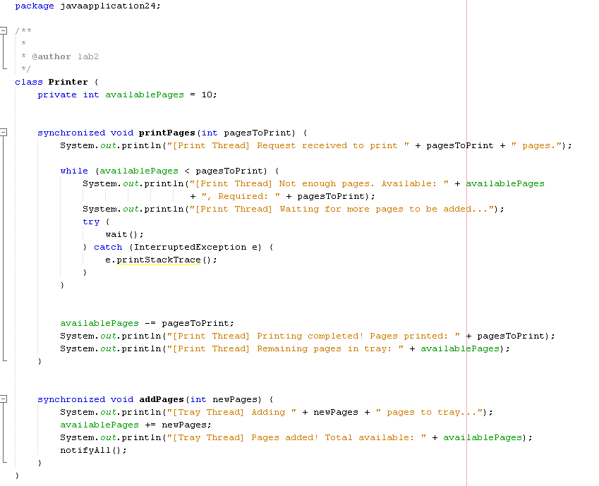
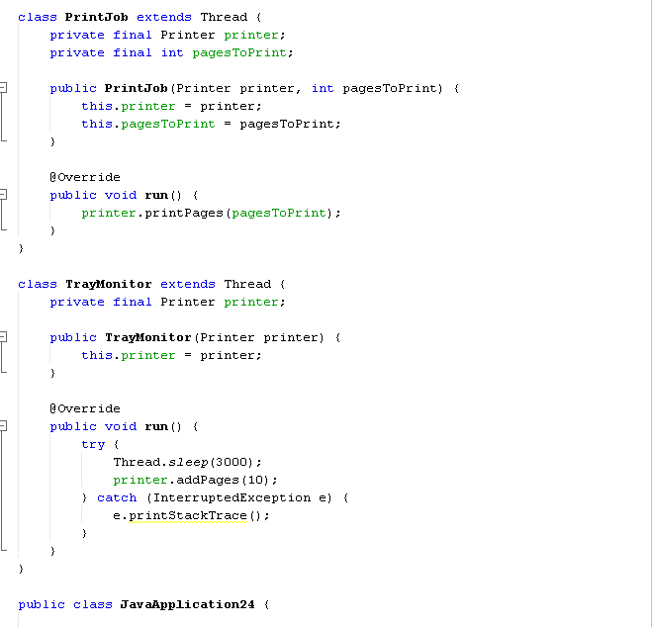

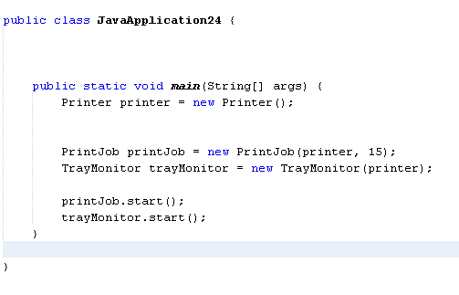

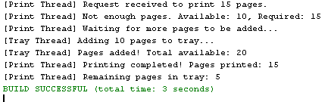
2.Create an inter thread communication program of printer job by implementing two threads, one for calculating the remaining pages in printer tray and other one will print the pages that are pending on queue. (Hint: If total pages are 10 and user sends job for 15 pages than print thread will be on wait and will be notified once available pages are equal or greater than printing pages).
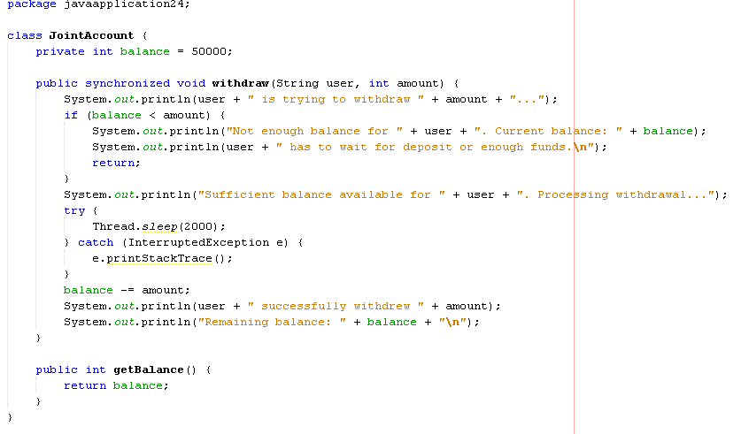
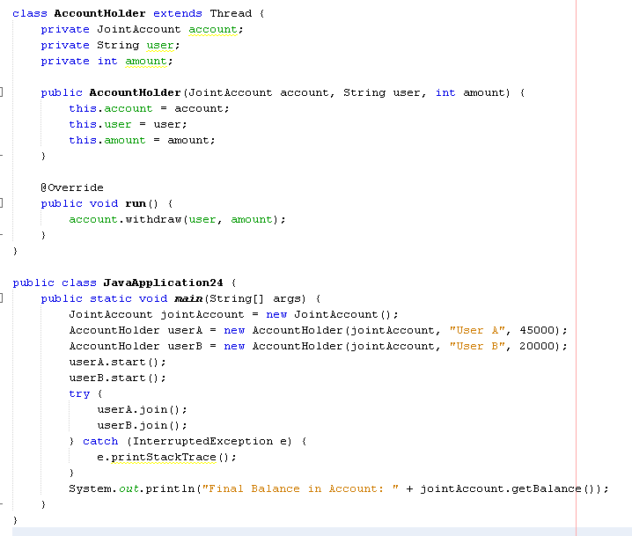
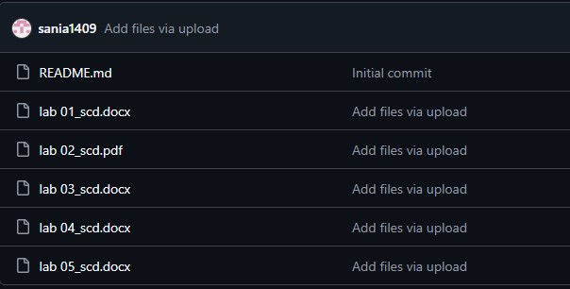
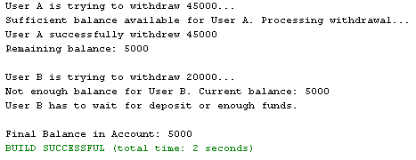
Zainab1 Add files via upload

